ABSTRACT:
Speed Control for The BrushLess Direct Current (BLDC) Motor in Simulink

1- Mathematical model of BLDC motor
2- PI Controller Design Finding Kp and Ki
3- Whole Speed Control System

TITLE:
Brushless DC Motor Speed Control

PROJECT PERIOD:
01.10.2013 ÷ 21.01.2014

SUBJECT:
CAD of Control Systems

PROJECT GROUP:
7th semester Macrofaculty

GROUP MEMBERS:
Ismail Kalay
Adam Śmiałkowski
Krzysztof Żabiński

SUPERVISOR:

NUMBER OF PAGES:

1- Mathematical model of BLDC motor in Simulink

Steady-Space Mathematical Model of BLDC Motor:

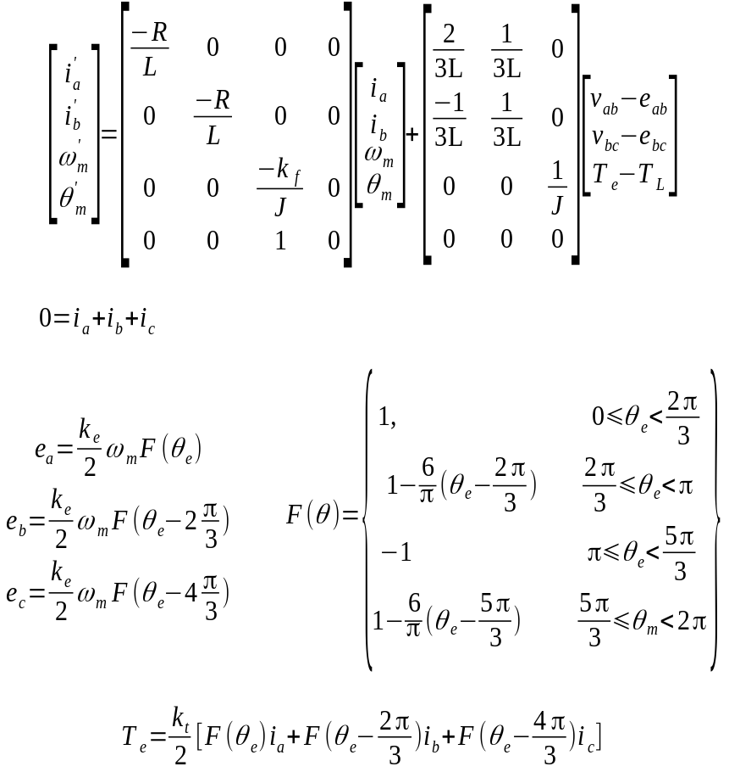

BLDC Motor Block in Simulink:

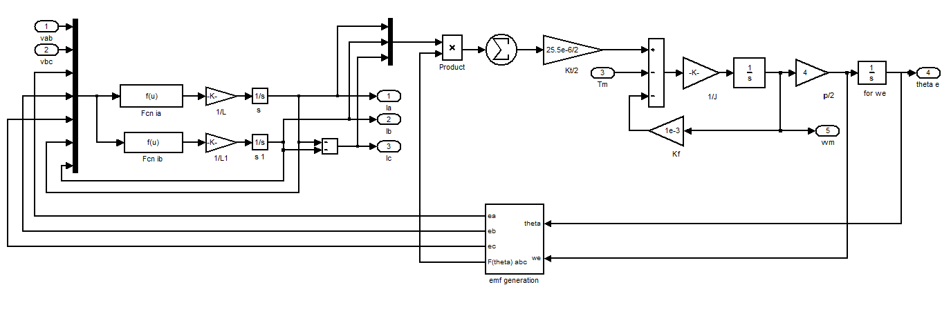Fig 1: Motor Block

Inverter Block in Simulink:
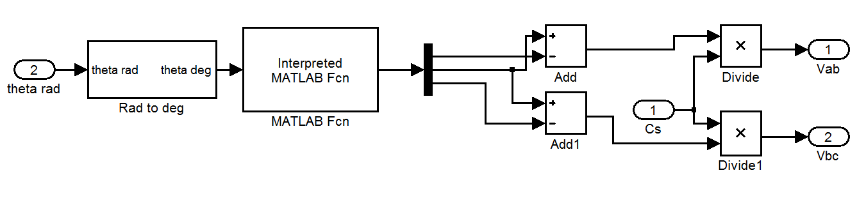Fig 2: Inverter Block
emfg.m Matlab Function
function y=emfg(u)
vi=1;
vh=vi/2;
if(u>0)&&(u<=60)
y=[vi;vh;0];
elseif(u>60)&&(u<=120)
y=[vh;vi;0];
elseif(u>120)&&(u<=180)
y=[0;vi;vh];
elseif (u>-180)&&(u<=-120)
y=[0;vh;vi];
elseif(u>-120)&&(u<=-60)
y=[vh;0;vi];
elseif(u>-60)&&(u<=0)
y=[vi;0;vh];
end

2-PI Controller (Ziegler – Nichols I)Transfer Function of BLDC Motor: 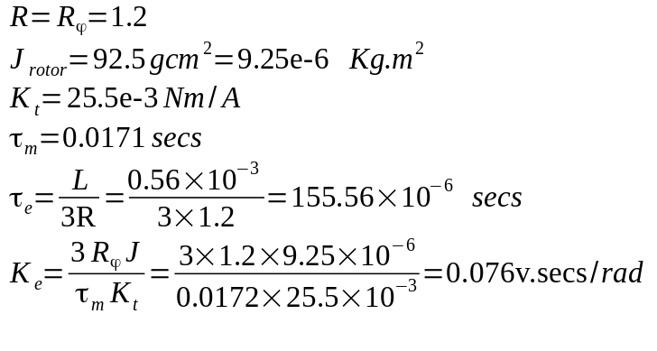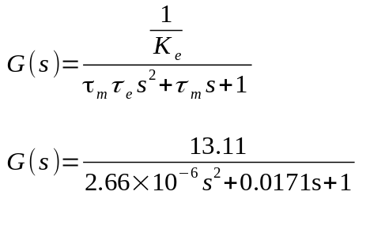
Parameters are used by EC 45 ﬂat 45 mm, brushless, 30 Watt Maxon Motor
openloopstepresponse.m
clear
close all
% Maxon flat motor parameters used in the modeling
R = 1.2; % Ohms, Terminal Resistance phase to phase
L = 0.560e-3; % Henrys, Terminal Inductance phase to phase
Kt = 25.5e-3; % Nm/A, Torque constant
Ks = 37.4; % rpm/V, Speed constant
tm = 17.1e-3; % seconds, s, Mechanical Time constant
J = 92.5e-7; % kg.m^2, Rotor inertia, given in gcm^2
p = 3; % Number of phases
te = L/(p*R); % seconds, s, Electrical Time constant
Ke = (3*R*J)/(tm*Kt); % Back emf constant
% Transfer function without 13.11
G = tf([1/(tm*te)],[1 tm/(tm*te) 1/(tm*te)]);
%ziegler-nichols I
wn=sqrt(1/(tm*te));ksi=(tm/(2*tm*te))/wn;
k1=(ksi+(ksi^2-1)^(1/2))*wn;k2=(ksi-(ksi^2-1)^(1/2))*wn;
tb=(log(k1)-log(k2))/(k1-k2);
y0=1+(wn/(2*((ksi^2-1)^(1/2))))*((k2*exp(-k1*tb)-k1*exp(-k2*tb))/(k1*k2));
m=wn*(-exp(-k1*tb)+exp(-k2*tb))/(2*((ksi^2-1)^(1/2)));
n=y0-m*tb;
L=-n/m;
T=-L+(1-n)/m;
Kp=T*0.9/(L*13.11);
Ki=(Kp*0.3)/(L*13.11);%1/Ke = 13.11 gain
% Plots the Step Response diagram
figure;step(G, 0.5);
title('Open Loop Step Response diagram');
xlabel('Time, secs')
ylabel('Voltage, volts')
grid on;
Kp
Ki

PI Control Block in Simulink:

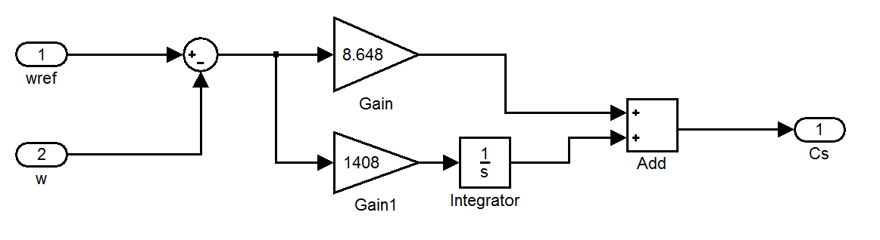Fig 4: Control Block

EC 45 ﬂat 45 mm, brushless, 30 Watt
Find below the major extracted parameters used for the modeling task.
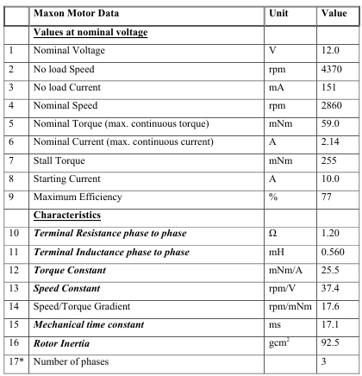

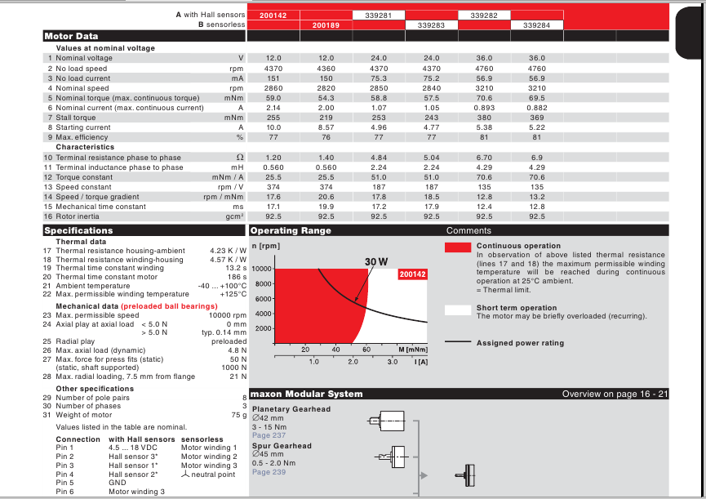

References:
- https://publications.theseus.fi/bitstream/handle/10024/7467/Oludayo%20Oguntoyinbo.pdf
- http://www.aviton.spb.ru/files/doc/pdf/maxon/193.pdf
- http://www.mathworks.com/matlabcentral/fileexchange/42060-speed-control-of-brush-less-dc-motor/all_files

